Project Report
Streamlining IT Procurement: Automating Standard Laptop Orders with Flow Designer
Date | 08 October 2026
Team ID | 9100Smartgirls
Project Name | Streamlining IT Procurement: Automating Standard Laptop Orders with Flow Designer
Team Members | Teamleader-Harini M,Team member-Nishanthini S

Contents
1. INTRODUCTION
1.1 Project Overview
1.2 Purpose
2. IDEATION PHASE
2.1 Problem Statement
2.2 Empathy Map Canvas
2.3 Brainstorming
3. REQUIREMENT ANALYSIS
3.1 Customer Journey map
3.2 Solution Requirement
3.3 Data Flow Diagram
3.4 Technology Stack
4. PROJECT DESIGN
4.1 Problem Solution Fit
4.2 Proposed Solution
4.3 Solution Architecture
5. PROJECT PLANNING & SCHEDULING
5.1 Project Planning
6. FUNCTIONAL AND PERFORMANCE TESTING
6.1 Performance Testing
7. RESULTS
7.1 Output Screenshots
8. ADVANTAGES & DISADVANTAGES
9. CONCLUSION
10. FUTURE SCOPE
11. APPENDIX
Source Code(if any)
Dataset Link
GitHub & Project Demo Link

1. INTRODUCTION
1.1 Project Overview
The current IT procurement process is largely manual, especially when ordering standard laptops. Laptops usually need to be configured before they are given to users, but this step can be missed or delayed. As a result, users wait longer for their laptops and the IT team spends extra time on manual tasks.
This project automates the procurement and configuration of standard laptops using ServiceNow Flow Designer. A flow named "Standard Laptop Task" is triggered from the Service Catalog. It uses the Create Catalog Task action to create a configuration task for the ordered Standard Laptop item, sets the Short Description and Description to "Laptop needs to be configured", and assigns the task to the Hardware group. The flow is attached to the Standard Laptop catalog item through Process Engine. The solution is no-code and uses no scripting.
1.2 Purpose
The purpose of the project is to make it easier for users to request standard laptops and to ensure that the laptops are configured on time. It reduces manual work and common mistakes in the procurement process, assigns tasks to the right IT team members so that resources are used effectively, and improves the overall speed, efficiency and productivity of IT procurement.
2. IDEATION PHASE
2.1 Problem Statement
Problem Statement (PS) | I am (Customer) | I’m trying to | But | Because | Which makes me feel
PS-1 | IT procurement team member | Order standard laptops efficiently | I must create and assign the configuration task manually | Every order needs manual follow-up | Frustrated and burdened
PS-2 | User requesting a laptop | Get a configured laptop quickly | The laptop is delayed | The configuration step can be missed or delayed | Impatient and unproductive
PS-3 | Hardware team member | Configure laptops on arrival | I do not receive a task for the new laptop | Tasks are not assigned automatically | Uncertain and concerned about delays

2.2 Empathy Map Canvas
The empathy maps for the user requesting a laptop and for the IT procurement and hardware teams show that users are impatient and uncertain while they wait for their laptops, while the IT teams are burdened by manual task creation and worried that configuration steps can be missed. The full empathy maps are given in the Empathy Map Canvas document.
2.3 Brainstorming
The team listed and grouped ideas for request capture, automation logic, task assignment, and flow linking and tracking. Based on impact and effort, ordering through the Standard Laptop catalog item, a Flow Designer flow with the Service Catalog trigger, the Create Catalog Task action, automatic assignment to the Hardware group and linking the flow through Process Engine were selected. Email notification, catalog items for other hardware, SLA tracking and automatic approval routing were recorded as future enhancements.
3. REQUIREMENT ANALYSIS
3.1 Customer Journey map
The journey of a user moves through five stages: realising that a new laptop is needed (Entice), opening Service Catalog > Hardware > Standard Laptop (Enter), clicking Order Now and getting the request approved (Engage), the configuration task being created and assigned to the hardware team automatically (Exit), and the hardware team configuring the laptop for the user (Extend). Automatic task creation removes the manual step that could be missed or delayed.
3.2 Solution Requirement
FR No. | Functional Requirement (Epic) | Sub Requirement (Story / Sub-Task)
FR-1 | Service Catalog Ordering | Standard Laptop item in the Hardware category; Order Now; Order Status and Request Number
FR-2 | Request Approval | Approval of the request from the Approvers section of the Request record
FR-3 | Flow Creation | Flow "Standard Laptop Task" with Application Global, Run As System User and the Service Catalog trigger
FR-4 | Catalog Task Creation | Create Catalog Task action: Short Description and Description "Laptop needs to be configured", Assignment Group Hardware, Approval Approved
FR-5 | Flow Assignment | Flow attached to the Standard Laptop item through Maintain Items and Process Engine
FR-6 | Task Tracking | Request, Requested Item and Catalog Task records show the status and the assigned group

FR No. | Non-Functional Requirement | Description
NFR-1 | Usability | The user only places the order with Order Now; no manual task creation is needed.
NFR-2 | Security | The request is approved from the Approvers section; the flow runs as System User.
NFR-3 | Reliability | The same configuration task is created in the same way for every approved order.
NFR-4 | Performance | The configuration task is created automatically by the flow without manual action.
NFR-5 | Availability | Depends on the availability of the ServiceNow instance.
NFR-6 | Scalability | Similar flows can be created for other catalog items without scripting.

3.3 Data Flow Diagram
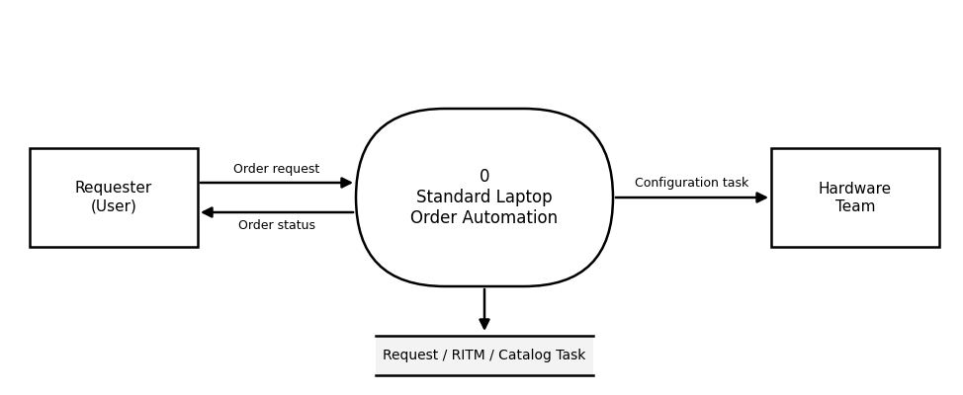
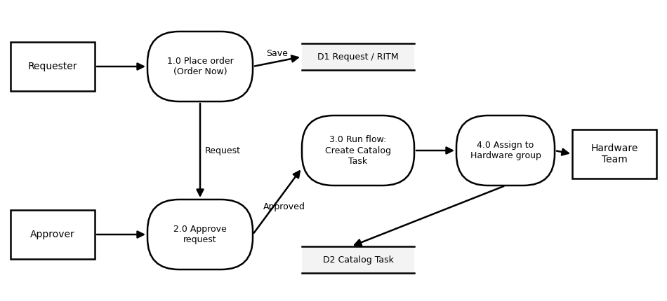
3.4 Technology Stack
S.No | Component | Technology
1 | User Interface | ServiceNow Service Catalog (Hardware > Standard Laptop > Order Now)
2 | Application Logic | Flow Designer: Service Catalog trigger and Create Catalog Task action
3 | Database | ServiceNow tables: Request, Requested Item and Catalog Task [sc_task]
4 | Flow Assignment | Maintain Items: Process Engine of the Standard Laptop catalog item
5 | Approval | Approvers section of the Request record
6 | Platform | ServiceNow instance (Personal Developer Instance)

4. PROJECT DESIGN
4.1 Problem Solution Fit
The problem is the manual and delay-prone handling of standard laptop orders. The solution fits the way users already order equipment: they place an order through the Service Catalog. A flow that starts from the catalog order and creates the configuration task for the hardware team removes the manual step without changing how users or approvers work.
4.2 Proposed Solution
A Flow Designer flow named "Standard Laptop Task" is triggered by the Service Catalog. It creates a catalog task for the Requested Item with the following configuration.
Component | Setting | Value
Flow | Application / Run As | Global / System User
Trigger | Trigger type | Service Catalog
Action | Action / Table | Create Catalog Task / Catalog Task [sc_task]
Action | Request Item | Requested Item record (data pill)
Action | Short Description and Description | Laptop needs to be configured
Action | Assignment Group | Hardware
Action | Approval | Approved

The flow is attached to the Standard Laptop catalog item through Maintain Items > Process Engine. When a user orders the laptop and the request is approved, the configuration task is created and assigned to the hardware team automatically.
4.3 Solution Architecture
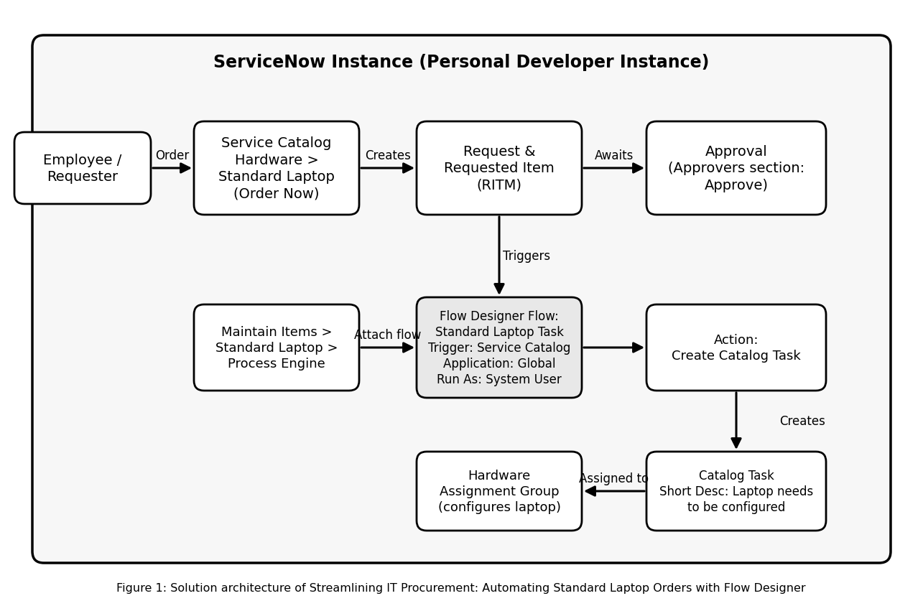
Flowchart of the laptop ordering flow
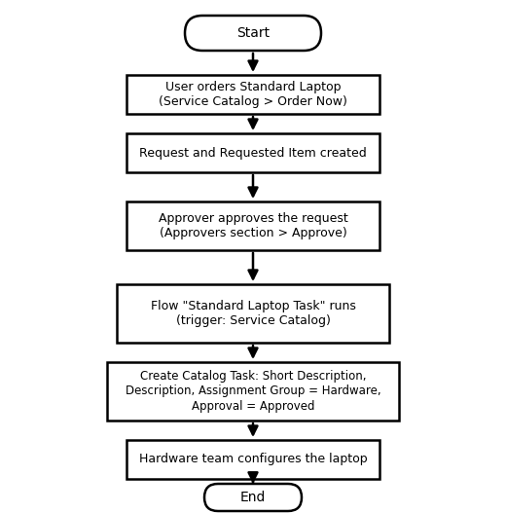
5. PROJECT PLANNING & SCHEDULING
5.1 Project Planning
The project was planned in three sprints of six days each, with 12 user stories and 30 story points in total. The velocity is 30 / 3 = 10 story points per sprint.
Sprint | Total Story Points | Duration | Start Date | End Date (Planned) | Points Completed | Release Date (Actual)
Sprint-1 | 10 | 6 Days | [START DATE] | [END DATE] | 10 | [RELEASE DATE]
Sprint-2 | 10 | 6 Days | [START DATE] | [END DATE] | 10 | [RELEASE DATE]
Sprint-3 | 10 | 6 Days | [START DATE] | [END DATE] | 10 | [RELEASE DATE]

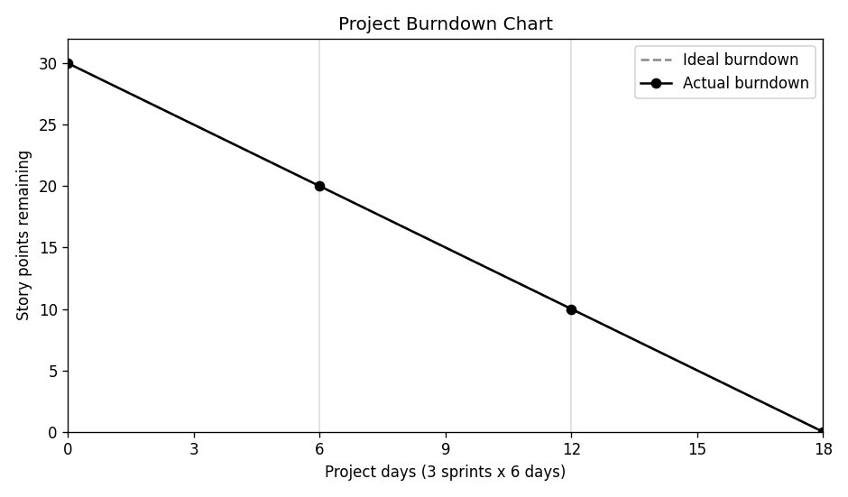
6. FUNCTIONAL AND PERFORMANCE TESTING
6.1 Performance Testing
Seven test cases were executed. The table below lists the test cases, expected results and actual results.
Test Case | Scenario | Expected Result | Actual Result | Result
TC-001 | Open the Standard Laptop item in the Service Catalog | Item opens with the Order Now button | Item opened with the Order Now button | Pass
TC-002 | Place an order for the Standard Laptop | Request submitted; Request Number shown | Request REQ0010001 submitted | Pass
TC-003 | View the request and its approver | Approver listed with state Requested | Approver listed with state Requested | Pass
TC-004 | Approve the request | Request is approved | Request approved from the Approvers section | Pass
TC-005 | Catalog task is created automatically | One catalog task listed under the Requested Item | SCTASK0010001 listed under RITM0010001 | Pass
TC-006 | Catalog task Short Description | "Laptop needs to be configured" | "Laptop needs to be Configured" (capital C) | Fail (minor)
TC-007 | Catalog task assignment and approval | Assignment Group = Hardware; Approval = Approved | Assignment Group = Hardware; Approval = Approved | Pass

Six of the seven test cases passed. The flow created the catalog task and assigned it to the Hardware group. The failed test case is a minor text issue: the Short Description appears as "Laptop needs to be Configured" with a capital C (BG-001).
Flow execution: catalog task listed under the Requested Item
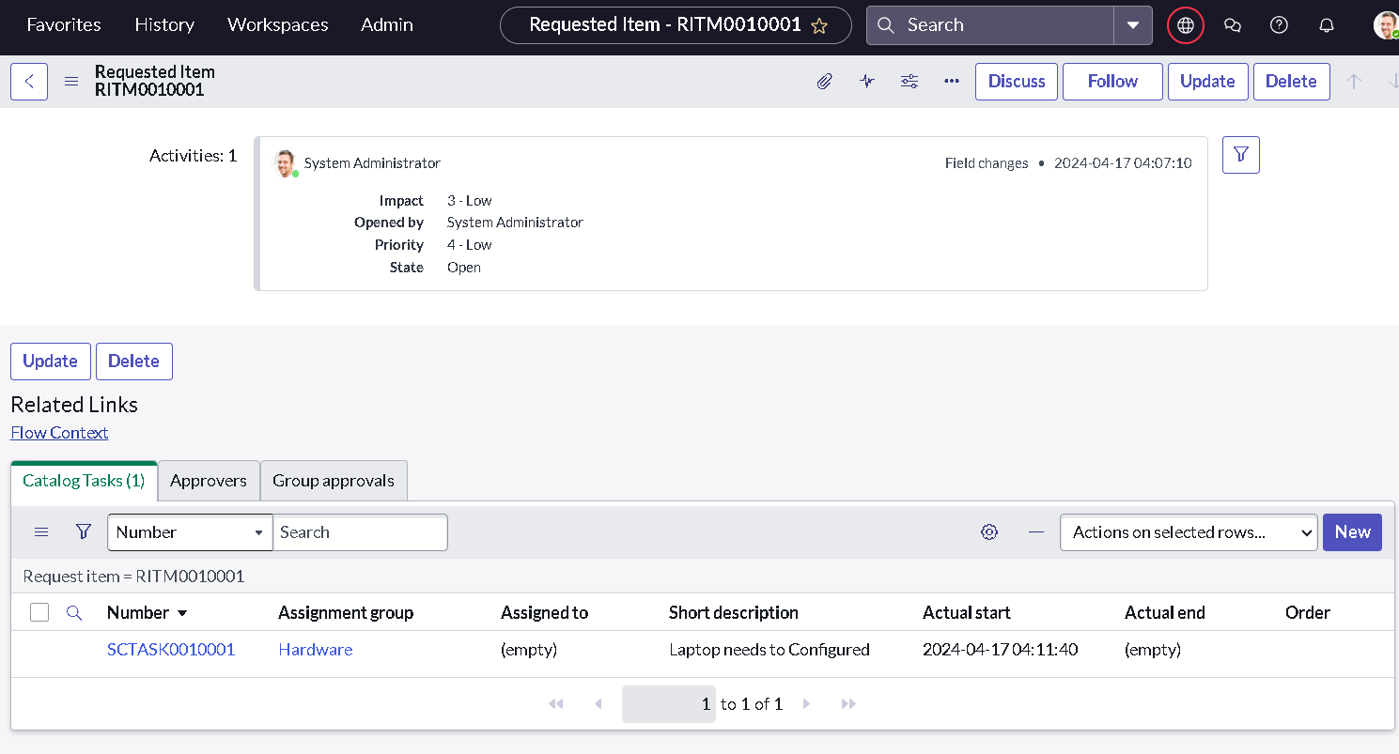

7. RESULTS
7.1 Output Screenshots
Results: after the Standard Laptop was ordered and the request approved, a catalog task was created under the Requested Item with the Short Description "Laptop needs to be configured" and the Hardware assignment group, without manual task creation.
Service Catalog order status
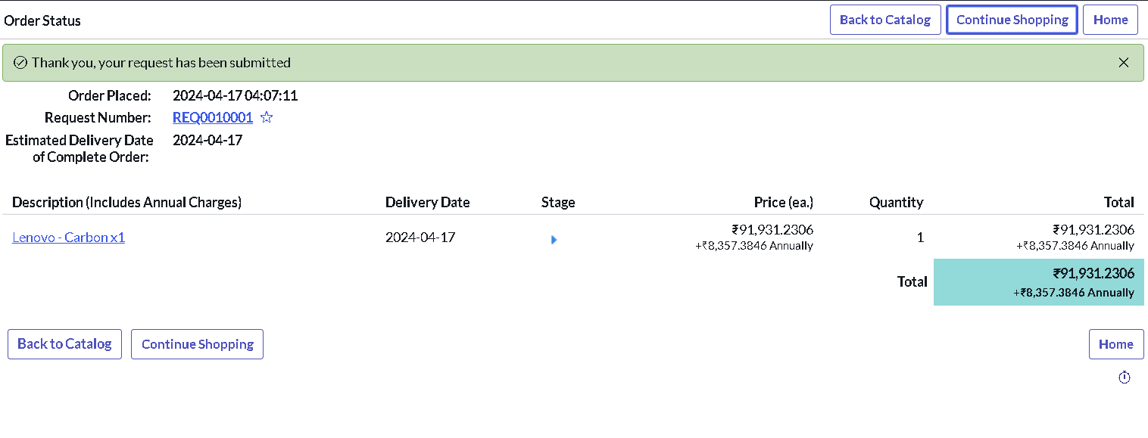

Flow Designer: Standard Laptop Task
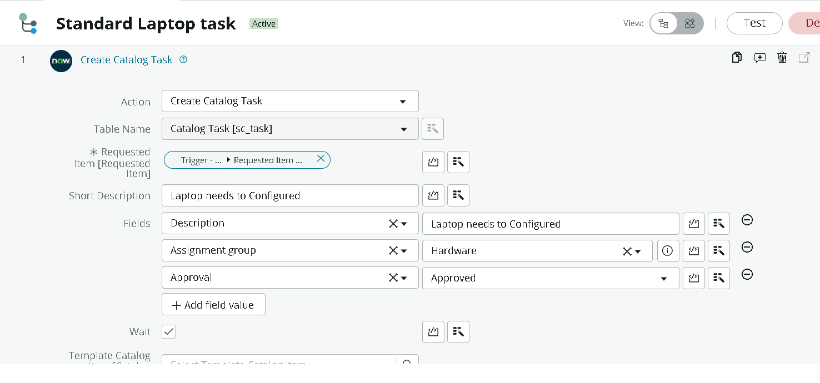

Catalog task created by the flow
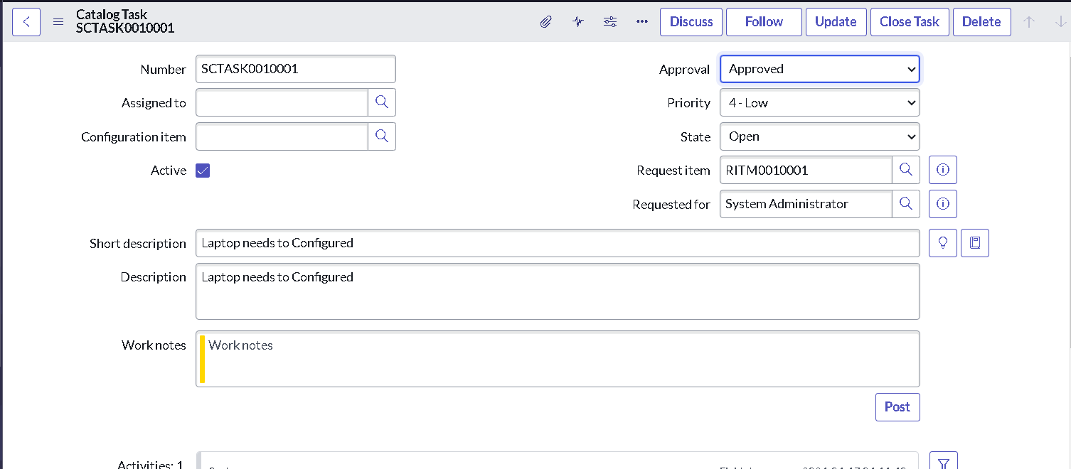

Approvers section of the request
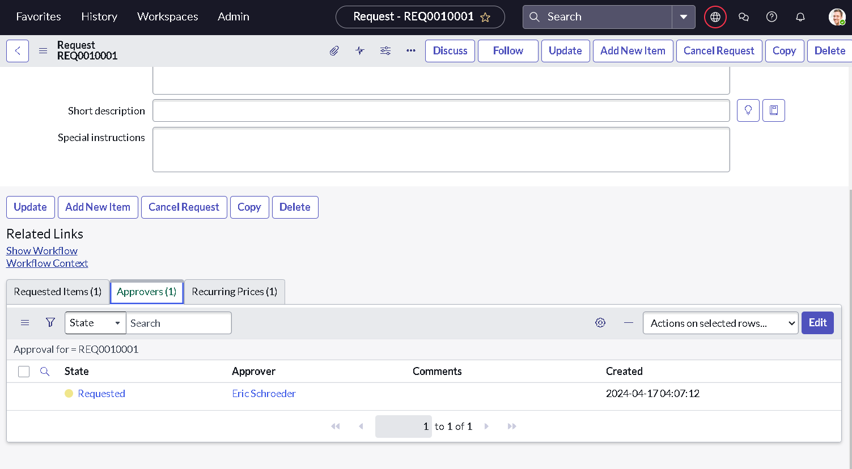

8. ADVANTAGES & DISADVANTAGES
Advantages | Disadvantages
Reduces manual effort in creating configuration tasks | Applies only to the Standard Laptop catalog item
Configuration task is created and assigned to the Hardware group automatically | Task text is fixed and the same for every order
Reduces the waiting time for users | No automatic notification to the requester yet
Avoids missed or delayed configuration steps | Approval routing is not automated
No-code solution that is easy to maintain | Depends on the availability of the ServiceNow instance
Uses the existing Service Catalog and approval process | One minor text issue (BG-001) is open

9. CONCLUSION
The Streamlining IT Procurement: Automating Standard Laptop Orders with Flow Designer project delivers an end-to-end automation for standard laptop procurement. Through a Flow Designer flow with the Service Catalog trigger and the Create Catalog Task action, a configuration task is created and assigned to the Hardware group once a Standard Laptop is ordered and approved. Linking the flow to the catalog item through Process Engine makes the automation run for every order of that item.
The project shows that ServiceNow Flow Designer can reduce manual work and the waiting time for users in IT procurement without scripting. The automated workflow helps the IT team manage tasks and resources more efficiently and makes the procurement process simpler and faster for both users and the IT team.
10. FUTURE SCOPE
• Send an email notification to the requester when the configuration task is created.
• Create similar flows for other hardware items such as monitors and mobile devices.
• Add SLA tracking and a dashboard for procurement tasks.
• Add automatic approval routing based on the type of request.
11. APPENDIX
Source Code (if any):
No custom script was written. The automation is built with Flow Designer and its configuration is summarised below.
Component | Configuration
Flow | Standard Laptop Task (Application: Global, Run As: System User)
Trigger | Service Catalog
Action | Create Catalog Task: Short Description and Description "Laptop needs to be configured"; Assignment Group Hardware; Approval Approved
Linked item | Standard Laptop (Maintain Items > Process Engine > Flow)

Dataset Link:
Not applicable. The project does not use an external dataset.
GitHub & Project Demo Link:
GitHub: [INSERT GITHUB LINK HERE]
Project Demo: [INSERT PROJECT DEMO LINK HERE]

